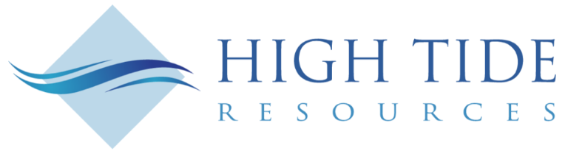

High Tide Resources Employs Hyperspectral Scan Technology on Labrador West Iron Project Drill Core

TORONTO, March 29, 2023 – High Tide Resources Corp. (“High Tide” or the “Company”) (CSE: HTRC) is pleased to report that it has participated in a hyperspectral scanning program in partnership with College of the North Atlantic (CNA) with funding provided by the National Research Council’s (NRC) Industrial Research Assistance Program.
High Tide is actively advancing its Labrador West Iron Project located in the southern Labrador Trough, home to four operating iron ore mines, and less than 20 kms northeast of IOC/Rio Tinto’s Carol Lake Mine complex in Labrador City, NL. On February 23, 2023 the Company released its maiden mineral resource estimate of 655 Mt @ 28.8% Fe in the inferred category.
The Hyperspectral Scanning Unit (HSU) laboratory offers world-class, high-resolution hyperspectral imaging capabilities in most currently accessible spectral ranges, spanning the Visible Near Infrared to the Longwave Infrared regions.
The HSU will identify mineralogy of the drill cores, especially the hematite vs. magnetite ratio, and contents of hydrated iron oxides, carbonates (including estimating mineral species), clay minerals (muscovite, kaolinite) and amphiboles (including roughly detecting subspecies, for example, of the deleterious mineral grunerite).
Steve Roebuck, Director, President & Interim CEO of High Tide Resources states, “Having access to the HSU has provided High Tide with a high-tech tool not normally available to an explorer while giving the geology team key information as we begin detailed modelling of the iron deposit. I would like to thank the team at College of the North Atlantic and the other programs who helped make this happen. This is just another example of how Newfoundland and Labrador, and in particular the Department of Industry, Energy and Technology, supports the vital mineral exploration industry.”

The HSU is primarily investigating mineralogical or other physio-chemical variability within geological samples. The technology is designed to quickly scan diamond drill core. The 5-camera system is able to scan a single 1.5 m long box in under a minute. This provides a better understanding of the geology and mineralogy of a mineral deposit and is a complement to physical logging as the HSU excels in revealing specific mineral composition that may be too small to see with the naked eye.
Approximately 1,000 m of core from three 2022 drill holes selected from the Labrador West Iron Project was scanned using the HSU at the NL government core storage facility in Happy Valley – Goose Bay.

College of the North Atlantic’s (CNA) $2.0 million state-of-the-artmobile hyperspectral scanning unit (HSU covers the Visible Near Infrared (VNIR) and Shortwave Infrared (SWIR) spectral ranges, but also includes the seldom investigated Midwave Infrared (MWIR) and Longwave Infrared (LWIR) spectral ranges. The instrument can, therefore, cover the entirety of the 400-5,400 nm spectral range, with the addition of the 7,800-12,000 nm region. The unit is designed for high-resolution close-range (1 mm/pixel) analysis of drill core and is also equipped with a RGB camera and a 3D laser profiler.
The HSU project is a collaboration – led by College of the North Atlantic (CNA), and funded by ACOA (Atlantic Canada Opportunities Agency) via its Regional Economic Growth though Innovation (REGI) program, the Government of Newfoundland and Labrador, and by industry partners Iron Ore Company of Canada, and Agnico Eagle Mines.

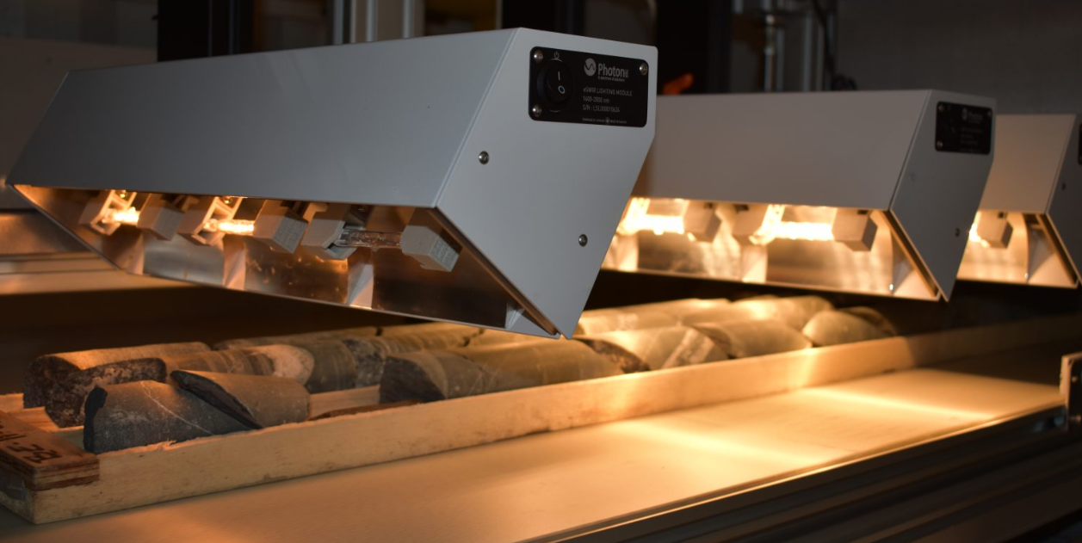
Figure 1. Drill core being scanned by hyperspectral cameras (photo credit NL IET)

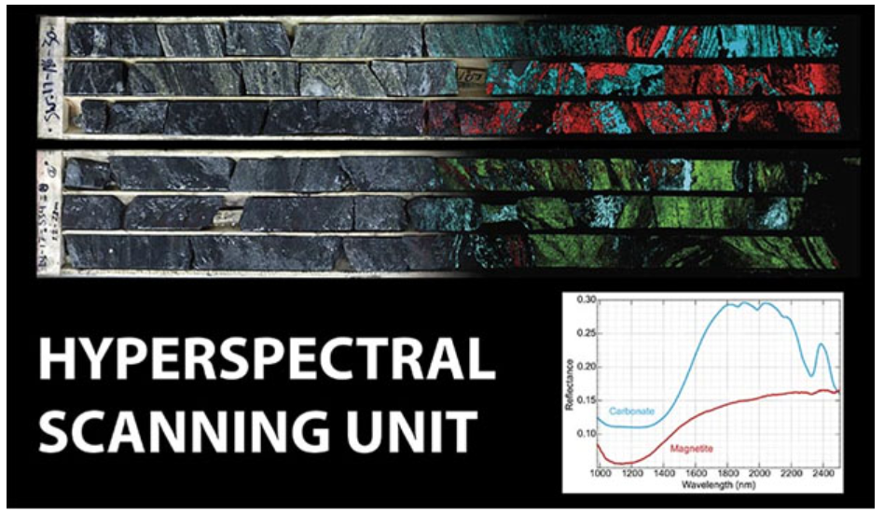
Figure 2. Iron and carbonate-rich drill core scanned using VNIR and SWIR hyperspectral cameras (photo credit CNA)
About High Tide
High Tide is focused on and committed to the development of mineral projects critical to infrastructure development using industry best practices combined with a strong social license from local communities. High Tide owns a 100% interest in the Labrador West Iron Project located adjacent to the Carol Lake Mine in Labrador City, NL and owns a 100% interest in the Lac Pegma copper-nickel-cobalt deposit located 50 kilometres southeast of Fermont, Quebec and is earning a 100% interest in the road accessible Clearcut Lithium Project located ~75 kilometres southwest of Val d’Or, Quebec and the road accessible Big Bang Lithium Project located ~275 kilometres northeast of Thunder Bay, Ontario. Majority shareholder Avidian Gold (TSX.V: AVG) controls approximately 30% of High Tide’s outstanding shares.
Further details on the Company, including a NI 43-101 technical report on the Labrador West Iron property can be found on the Company’s website at www.hightideresources.com .

Qualified Person

The technical information contained in this news release has been approved by Steve Roebuck,
P.Geo., Director, President and Interim CEO of High Tide, who is a Qualified Person as defined in "National Instrument 43-101, Standards of Disclosure for Mineral Projects."

For further information, please contact:

Steve Roebuck
Director, President & Interim CEO
Mobile: (905) 741-5458
Email: sroebuck@hightideresources.com
Neither Canadian Securities Exchange nor its Regulation Services Provider (as that term is defined in the policies of the Canadian Securities Exchange) accepts responsibility for the adequacy or accuracy of this news release.
Forward looking information
This news release includes certain "forward-looking statements" which are not comprised of historical facts. Forward-looking statements include estimates and statements that describe the Company’s future plans, objectives or goals, including words to the effect that the Company or management expects a stated condition or result to occur. Forward-looking statements may be identified by such terms as “believes”, “anticipates”, “expects”, “estimates”, “may”, “could”, “would”, “will”, or “plan”. Since forward-looking statements are based on assumptions and address future events and conditions, by their very nature they involve inherent risks and uncertainties. Although these statements are based on information currently available to the Company, the Company provides no assurance that actual results will meet management’s expectations. Risks, uncertainties and other factors involved with forward-looking information could cause actual events, results, performance, prospects and opportunities to differ materially from those expressed or implied by such forward-looking information. Forward looking information in this news release includes, but is not limited to, closing of the Agreement, exercising the Option, the acquisition of low cost and potentially high reward lithium projects, the ability to keep exploration costs low, expected access to regional lithium processing hubs, the Company’s objectives, goals or future plans, statements, exploration results, potential mineralization, the estimation of mineral resources, exploration and mine development plans, timing of the commencement of operations and estimates of market conditions. Factors that could cause actual results to differ materially from such forward-looking information include, but are not limited to: the ability to anticipate and counteract the effects of COVID-19 pandemic on the business of the Company, including without limitation the effects of COVID-19 on the capital markets, commodity prices supply chain disruptions, restrictions on labour and workplace attendance and local and international travel, failure to receive requisite approvals in respect of the foregoing, failure to identify mineral resources, failure to convert estimated mineral resources to reserves, the inability to complete a feasibility study which recommends a production decision, the preliminary nature of metallurgical test results, delays in obtaining or failures to obtain required governmental, environmental or other project approvals, political risks, inability to fulfill the duty to accommodate First Nations and other indigenous peoples, uncertainties relating to the availability and costs of financing needed in the future, changes in equity markets, inflation, changes in exchange rates, fluctuations in commodity prices, delays in the development of projects, capital and operating costs varying significantly from estimates and the other risks involved in the mineral exploration and development industry, and those risks set out in the Company’s public documents filed on SEDAR. Although the Company believes that the assumptions and factors used in preparing the forward-looking information in this news release are reasonable, undue reliance should not be placed on such information, which only applies as of the date of this news release, and no assurance can be given that such events will occur in the disclosed time frames or at all. The Company disclaims any intention or obligation to update or revise any forward-looking information, whether as a result of new information, future events or otherwise, other than as required by law.

