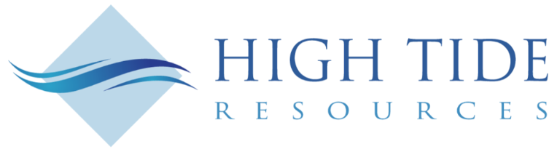

High Tide Resources Completes Airborne Geophysical Survey at its Clearcut Lithium Project in Quebec

TORONTO, October 26, 2022 – High Tide Resources Corp. (“High Tide” or the “Company”) (CSE: HTRC) is pleased to announce that it has completed a high-resolution heliborne magnetic & spectrometric survey (Figure 1) at its 14,400-hectare Clearcut Lithium Project (‘Property’) located in the emerging Cadillac-Pontiac lithium camp southwest of Val d’Or, Quebec (Figure 2).
Steve Roebuck, Director, President & Interim CEO of High Tide states, “The Clearcut Lithium project in Quebec represents an exceptional opportunity for both High Tide and Avidian shareholders. Given the recent activity in the domestic and global lithium markets, with record high prices and very strong demand from the electric vehicle and battery storage markets, the company is well positioned to benefit from this massive increase in demand.”
The Property consists of 249 claims made accessible by a network of logging roads (Figure 3) which increases efficiency and reduces exploration costs. Quebec MERN Report DP-338 issued in 1975 indicates that the Property is underlain almost entirely by granite with pegmatite. The Company and its technical advisors are in the process of reviewing the recently acquired data and are preparing for a site investigation in the coming weeks. More information will be shared as the data is processed and targets selected.
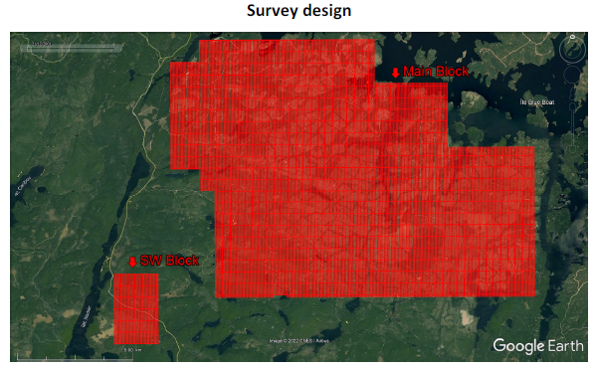
Figure 1: Clearcut Lithium geophysical survey design

About High Tide
High Tide is focused on and committed to the development of advanced-stage mineral projects in Canada using industry best practices combined with a strong social license from local communities. High Tide owns a 100% interest in the Labrador West Iron Project located adjacent to the Carol Lake Mine in Labrador City, NF and owns a 100% interest in the Lac Pegma copper-nickel-cobalt deposit located `50 kilometres southeast of Fermont, Quebec and is earning a 100% interest in the Clearcut Lithium Project located ~75 kilometres southwest of Val d’Or, Quebec. Majority shareholder Avidian Gold (TSX.V: AVG) controls approximately 33% of High Tide’s outstanding shares.
Further details on the Company, including a NI 43-101 technical report on the Labrador West Iron property can be found on the Company’s website at www.hightideresources.com .
Qualified Person

The technical information contained in this news release has been approved by Steve Roebuck,
P.Geo., Director, President and Interim CEO of High Tide, who is a Qualified Person as defined in "National Instrument 43-101, Standards of Disclosure for Mineral Projects."

For further information, please contact:

Steve Roebuck
Director, President & Interim CEO
Mobile: (905) 741-5458
Email: sroebuck@hightideresources.com
Neither Canadian Securities Exchange nor its Regulation Services Provider (as that term is defined in the policies of the Canadian Securities Exchange) accepts responsibility for the adequacy or accuracy of this news release.
Forward-looking information
This news release includes certain "forward-looking statements" which are not comprised of historical facts. Forward-looking statements include estimates and statements that describe the Company’s future plans, objectives or goals, including words to the effect that the Company or management expects a stated condition or result to occur. Forward-looking statements may be identified by such terms as “believes”, “anticipates”, “expects”, “estimates”, “may”, “could”, “would”, “will”, or “plan”. Since forward-looking statements are based on assumptions and address future events and conditions, by their very nature they involve inherent risks and uncertainties. Although these statements are based on information currently available to the Company, the Company provides no assurance that actual results will meet management’s expectations. Risks, uncertainties and other factors involved with forward-looking information could cause actual events, results, performance, prospects and opportunities to differ materially from those expressed or implied by such forward-looking information. Forward looking information in this news release includes, but is not limited to, listing of the Company’s shares on the CSE, the Company’s objectives, goals or future plans, statements, exploration results, potential mineralization, the estimation of mineral resources, exploration and mine development plans, timing of the commencement of operations and estimates of market conditions. Factors that could cause actual results to differ materially from such forward-looking information include, but are not limited to: the ability to anticipate and counteract the effects of COVID-19 pandemic on the business of the Company, including without limitation the effects of COVID-19 on the capital markets, commodity prices supply chain disruptions, restrictions on labour and workplace attendance and local and international travel, failure to receive requisite approvals in respect of the foregoing, failure to identify mineral resources, failure to convert estimated mineral resources to reserves, the inability to complete a feasibility study which recommends a production decision, the preliminary nature of metallurgical test results, delays in obtaining or failures to obtain required governmental, environmental or other project approvals, political risks, inability to fulfill the duty to accommodate First Nations and other indigenous peoples, uncertainties relating to the availability and costs of financing needed in the future, changes in equity markets, inflation, changes in exchange rates, fluctuations in commodity prices, delays in the development of projects, capital and operating costs varying significantly from estimates and the other risks involved in the mineral exploration and development industry, and those risks set out in the Company’s public documents filed on SEDAR. Although the Company believes that the assumptions and factors used in preparing the forward-looking information in this news release are reasonable, undue reliance should not be placed on such information, which only applies as of the date of this news release, and no assurance can be given that such events will occur in the disclosed time frames or at all. The Company disclaims any intention or obligation to update or revise any forward-looking information, whether as a result of new information, future events or otherwise, other than as required by law.

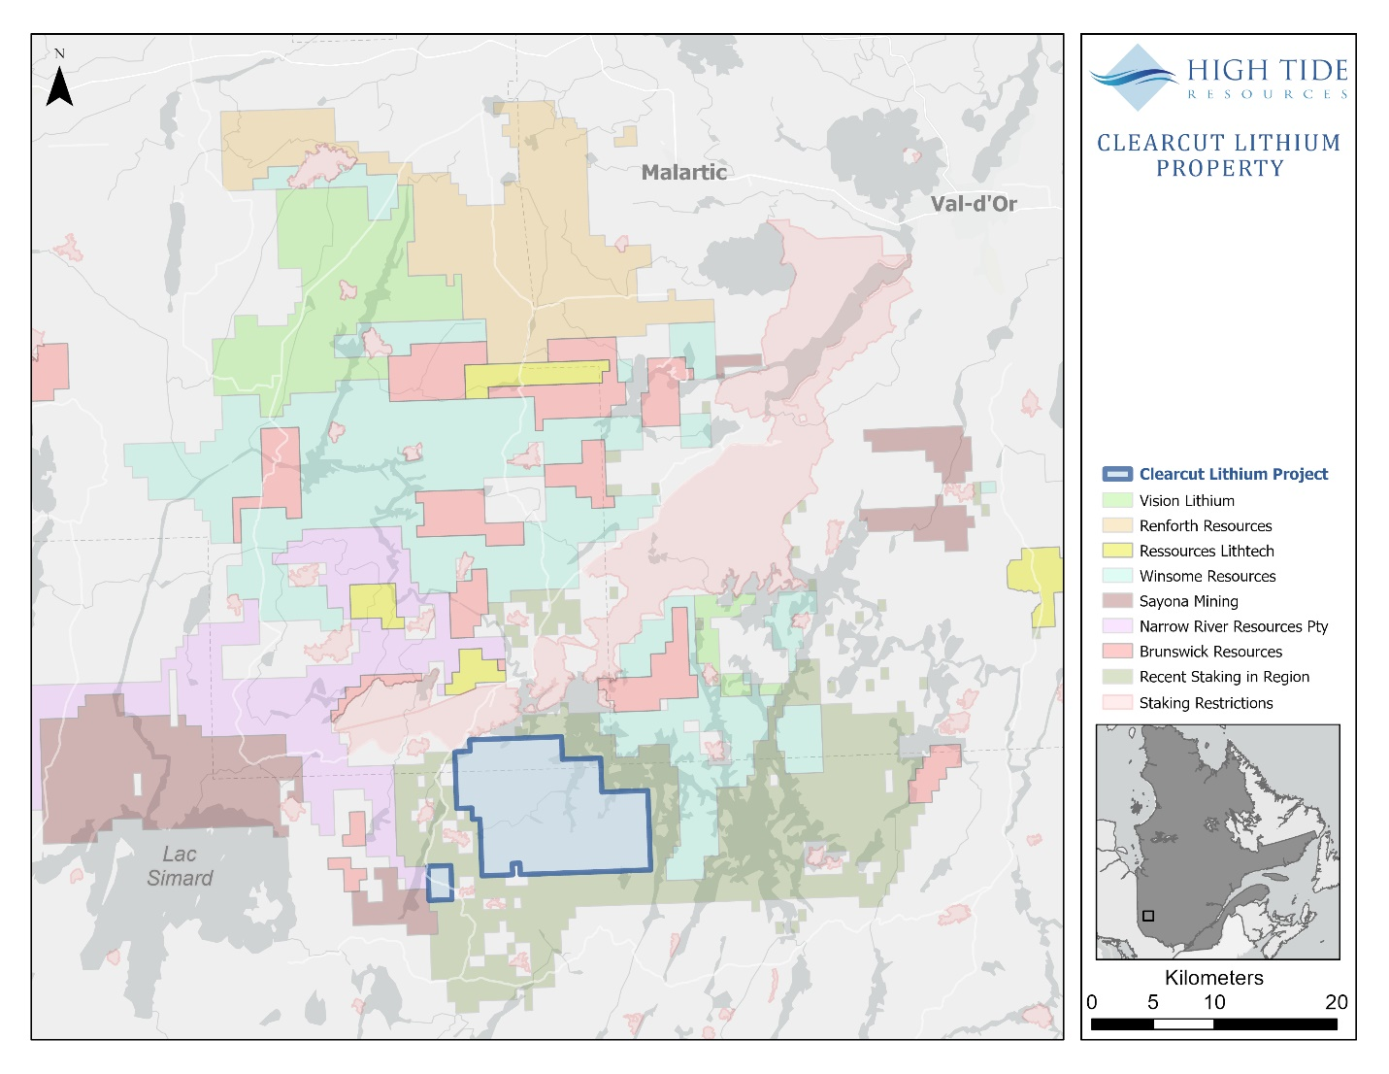
Figure 2: Clearcut Lithium Project location map with other company claims

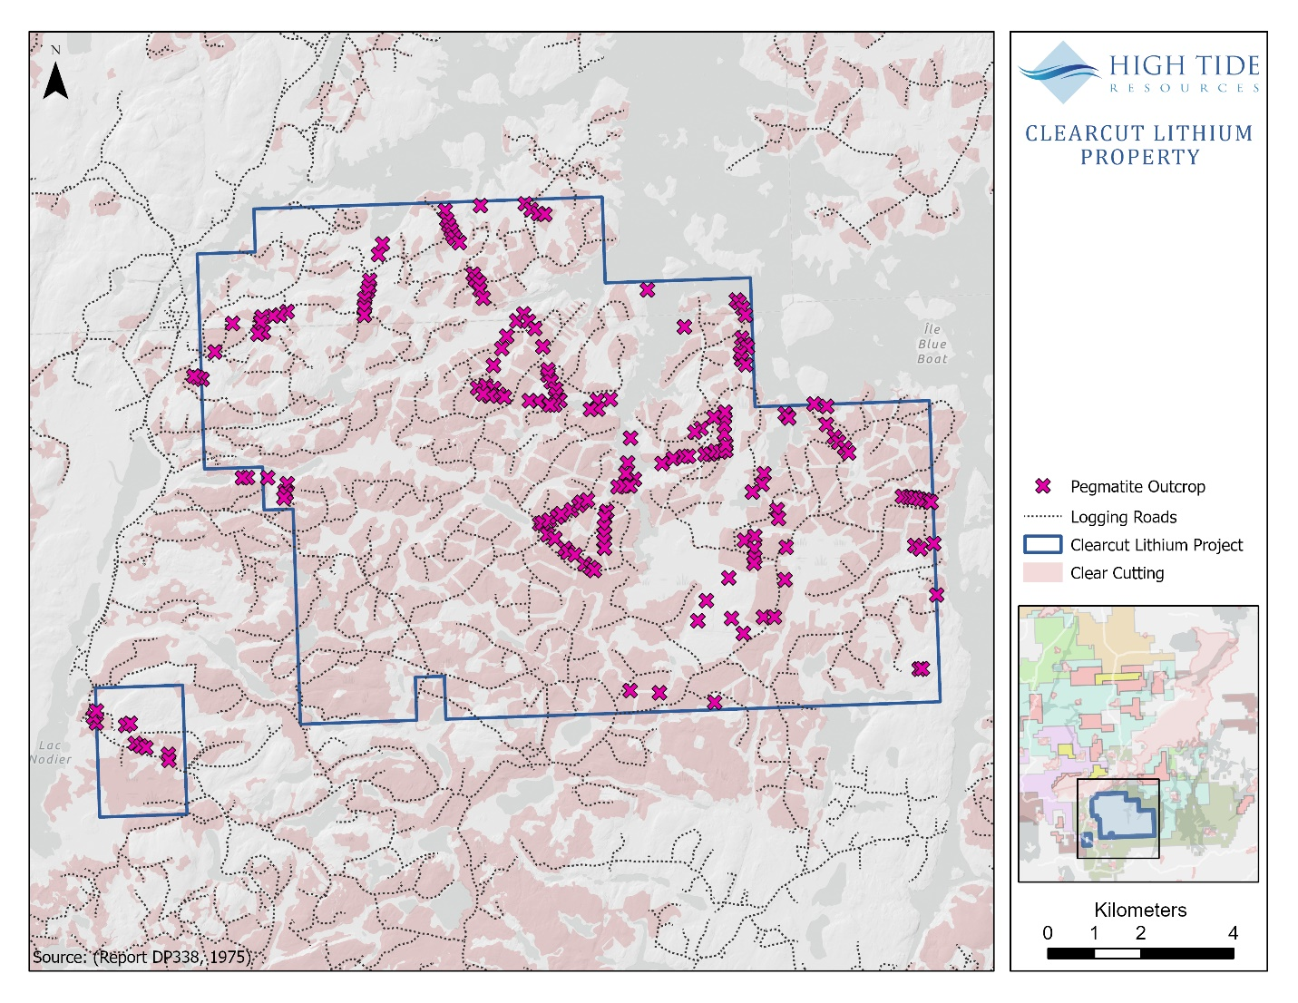
Figure 3. Clearcut Lithium Project property map with roads and possible pegmatite outcrops

