High Tide Resources Enters into Option Agreement to Acquire 100% of the Clearcut Lithium Project in Quebec

TORONTO, Ontario, July 14, 2022 – High Tide Resources Corp. (“High Tide” or the “Company”) (CSE: HTRC) is pleased to announce that it has entered into an option purchase agreement (the “Agreement”) to acquire a 100% interest in the Clearcut Lithium Project (the “Property”) located in the emerging Cadillac-Pontiac lithium camp in the Abitibi Témiscamingue region southwest of Val d’Or, Quebec (Figure 1).
The Property consists of 249 claims covering approximately 14,400 hectares within a network of logging roads allowing for good access and reduced exploration costs (Figure 2). Quebec MERN Report DP-338 issued in 1975 indicates that the Property is underlain almost entirely by granite with pegmatite.
Steve Roebuck, Director, President & Interim CEO of High Tide states, “Adding the Clearcut Lithium Project to High Tide’s project portfolio is a low-risk and potentially high-reward opportunity for all our shareholders. Lithium is in high demand making Clearcut a natural fit alongside our Lac Pegma Copper-Nickel-Cobalt Project that further diversifies our battery metals projects along with our flagship Labrador West Iron Project.”
Companies already active in the Cadillac-Pontiac camp include Winsome Resources, Sayona Mining, Vision Lithium, Brunswick Exploration and Renforth Resources. On February 22, 2022, Vision Lithium reported 2.17% Li2O over 5.5 metres from a channel sample taken from its nearby Cadillac Lithium Property confirms the presence of spodumene-bearing pegmatite dykes in the Cadillac-Pontiac camp.
Increasing worldwide demand for lithium from the nascent battery sector has focused exploration on areas of historical pegmatite-type lithium deposits. Since 2016 Sayona Mining Ltd. has accelerated exploration and development of the Authier lithium deposit and the recently acquired, past-producing North American lithium mine in the Preissac-Lacorne-Lamotte area located just 20 kilometres to the north of the Cadillac-Pontiac camp. This advanced activity has resulted in a keen interest in the lithium potential of Cadillac-Pontiac where traditionally there has been very little exploration due to the focus on the rich gold and volcanogenic-type base metal deposits found in the prolific Abitibi Greenstone Belt lying just to the north.
Agreement Details
Pursuant to the Agreement, the Company may acquire a 100% interest in the Property by making aggregate cash payments of $100,000, issuing an aggregate of 1,000,000 common shares of the Company and incurring an aggregate of $1,000,000 in exploration expenditures on or before the third anniversary date of the Agreement. The Vendors will retain a 2.0% net smelter royalty, 0.5% of which may be purchased by the Company for $1,000,000. Further, the Company has agreed to make additional one-time milestone payments of $500,000 and $1,000,000 upon the filing of a positive feasibility study and upon the start of commercial production respectively. The milestone payments may be paid in cash or the issuance of shares at the Company’s discretion and shall be deemed to be an advance to the Vendors to be deducted against future royalty payments.
About High Tide
High Tide is focused on and committed to the development of advanced-stage mineral projects in Canada using industry best practices combined with a strong social license from local communities. High Tide owns a 100% interest in the Labrador West Iron Project located adjacent to the Carol Lake Mine in Labrador City, NF and owns a 100% interest in the Lac Pegma copper-nickel-cobalt deposit located 50 kilometres southeast of Fermont, Quebec. Majority shareholder and parent company Avidian Gold (TSX.V:AVG & OTCQB:AVGDF) controls approximately 30% of High Tide’s outstanding shares.
Further details on the Company, including a NI 43-101 technical report on the Labrador West Iron property can be found on the Company’s website at www.hightideresources.com .
Qualified Person

The technical information contained in this news release has been approved by Steve Roebuck,
P.Geo., Director, President and Interim CEO of High Tide, who is a Qualified Person as defined in "National Instrument 43-101, Standards of Disclosure for Mineral Projects."

For further information, please contact:

Steve Roebuck
Director, President & Interim CEO
Mobile: (905) 741-5458
Email: sroebuck@hightideresources.com
Neither Canadian Securities Exchange nor its Regulation Services Provider (as that term is defined in the policies of the Canadian Securities Exchange) accepts responsibility for the adequacy or accuracy of this news release.
Forward-looking information
This news release includes certain "forward-looking statements" which are not comprised of historical facts. Forward-looking statements include estimates and statements that describe the Company’s future plans, objectives or goals, including words to the effect that the Company or management expects a stated condition or result to occur. Forward-looking statements may be identified by such terms as “believes”, “anticipates”, “expects”, “estimates”, “may”, “could”, “would”, “will”, or “plan”. Since forward-looking statements are based on assumptions and address future events and conditions, by their very nature they involve inherent risks and uncertainties. Although these statements are based on information currently available to the Company, the Company provides no assurance that actual results will meet management’s expectations. Risks, uncertainties and other factors involved with forward-looking information could cause actual events, results, performance, prospects and opportunities to differ materially from those expressed or implied by such forward-looking information. Forward looking information in this news release includes, but is not limited to, listing of the Company’s shares on the CSE, the Company’s objectives, goals or future plans, statements, exploration results, potential mineralization, the estimation of mineral resources, exploration and mine development plans, timing of the commencement of operations and estimates of market conditions. Factors that could cause actual results to differ materially from such forward-looking information include, but are not limited to: the ability to anticipate and counteract the effects of COVID-19 pandemic on the business of the Company, including without limitation the effects of COVID-19 on the capital markets, commodity prices supply chain disruptions, restrictions on labour and workplace attendance and local and international travel, failure to receive requisite approvals in respect of the foregoing, failure to identify mineral resources, failure to convert estimated mineral resources to reserves, the inability to complete a feasibility study which recommends a production decision, the preliminary nature of metallurgical test results, delays in obtaining or failures to obtain required governmental, environmental or other project approvals, political risks, inability to fulfill the duty to accommodate First Nations and other indigenous peoples, uncertainties relating to the availability and costs of financing needed in the future, changes in equity markets, inflation, changes in exchange rates, fluctuations in commodity prices, delays in the development of projects, capital and operating costs varying significantly from estimates and the other risks involved in the mineral exploration and development industry, and those risks set out in the Company’s public documents filed on SEDAR. Although the Company believes that the assumptions and factors used in preparing the forward-looking information in this news release are reasonable, undue reliance should not be placed on such information, which only applies as of the date of this news release, and no assurance can be given that such events will occur in the disclosed time frames or at all. The Company disclaims any intention or obligation to update or revise any forward-looking information, whether as a result of new information, future events or otherwise, other than as required by law.

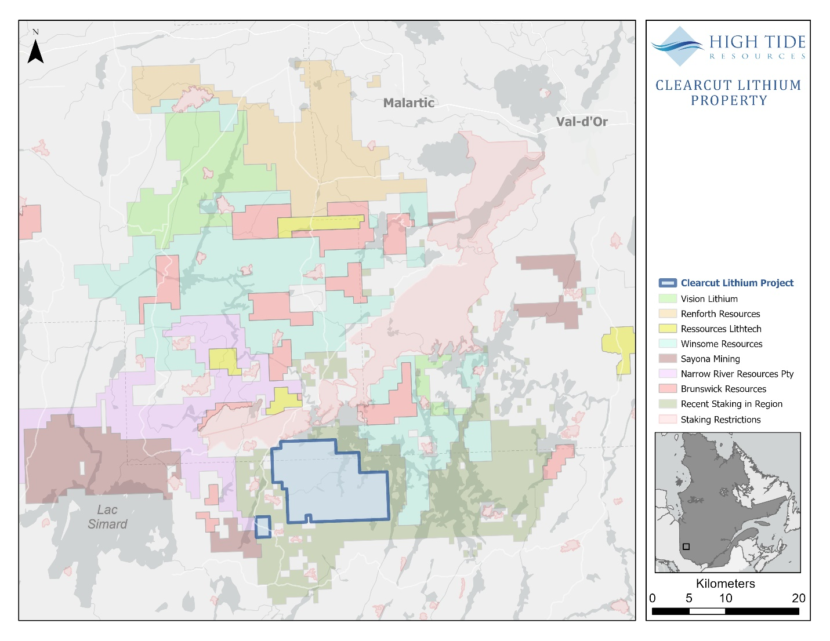
Figure 1: Clearcut Lithium Project location map

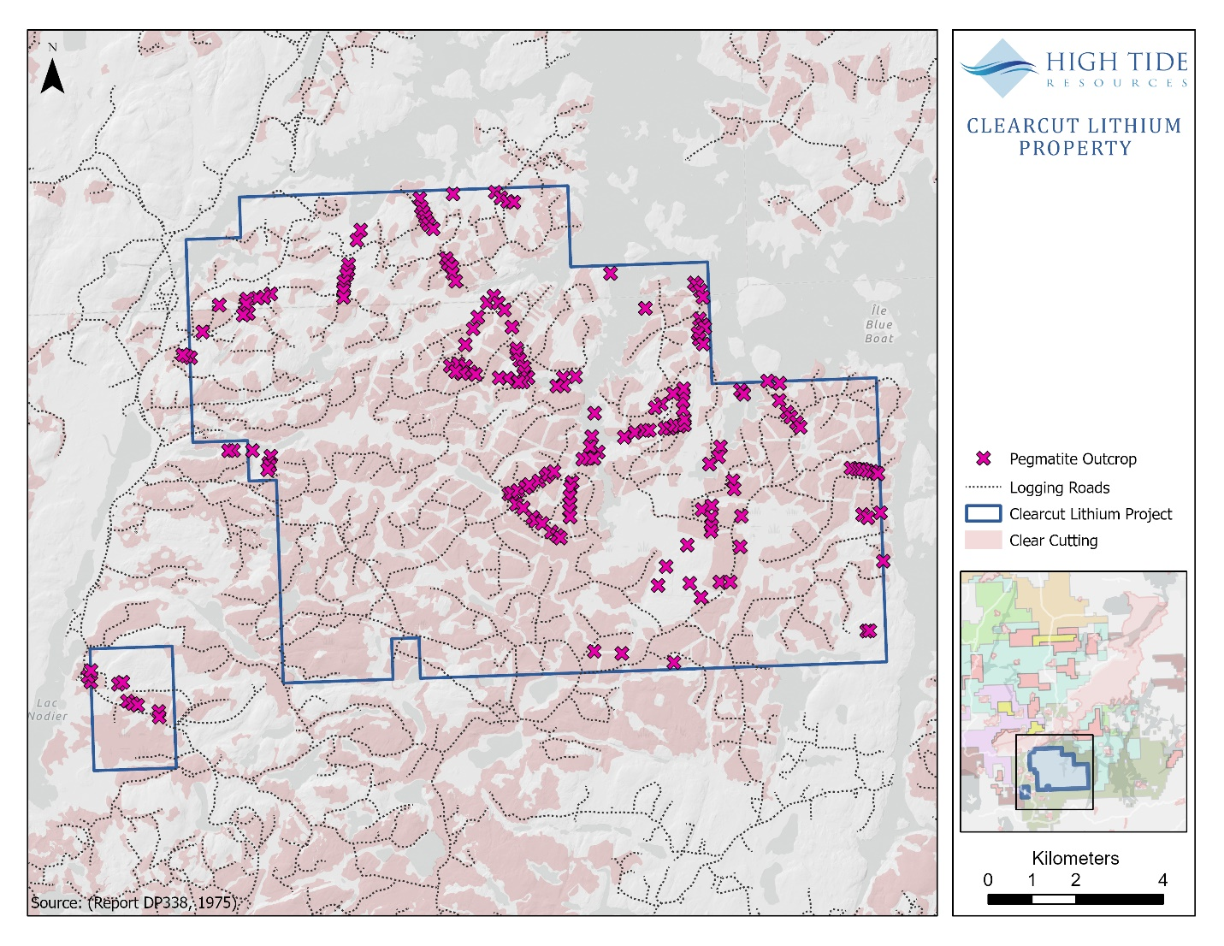
Figure 2. Clearcut Lithium Project property map

